**LAB EXAM: VLSM,VLAN,VTP,EIGRP/OSPF,NAT**

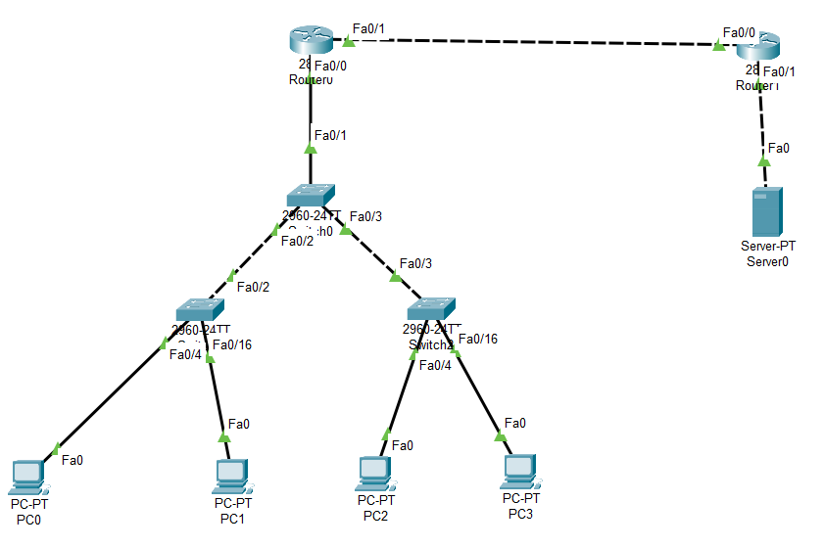

**Server switch:**

enable

config t

do show vtp status

**DOMAIN NAME**

vtp domain science

**CREATE VLAN & NAME ASSIGN**

vlan 10

name PHY

exit

vlan 20

name CHEM

exit

**TRUNK**

int range f0/1-f0/3

switchport mode trunk

switchport trunk allow vlan all

**Client switch1:**

enable

config t

**CLIENT MODE**

vtp mode client

do show vtp status

vtp domain science

do show vlan

**RANGE ASSIGN**

int range f0/4-f0/15

switchport mode access

switchport access vlan 10

exit

int range f0/16-f0/24

switchport mode access

switchport access vlan 20

exit

**Client switch2:**

enable

config t

**CLIENT MODE**

vtp mode client

do show vtp status

vtp domain science

do show vlan

**RANGE ASSIGN**

int range f0/4-f0/15

switchport mode access

switchport access vlan 10

exit

int range f0/16-f0/24

switchport mode access

switchport access vlan 20

exit

**Router1:**

enable

config t

int f0/0

no shut

**ENCAPSULATION**

int f0/0.20

encapsulation dot1q 20

ip address 10.0.0.1 255.255.248.0

exit

int f0/0.10

encapsulation dot1q 10

ip address 10.0.8.1 255.255.254.0

exit

int f0/1

ip address 150.0.0.1 255.255.252.0

no shut

exit

**DHCP POOL**

ip dhcp pool vp20

network 10.0.0.0 255.255.248.0

default 10.0.0.1

exit

ip dhcp pool vp10

network 10.0.8.0 255.255.254.0

default 10.0.8.1

exit

**OSPF**

router ospf 5300

network 10.0.0.0 0.0.7.255 area 0

network 10.0.8.0 0.0.1.255 area 0

network 150.0.0.0 0.0.3.255 area 0

exit

**NATTING**

access-list 10 permit 10.0.8.0 0.0.1.255

access-list 20 permit 10.0.0.0 0.0.7.255

ip nat inside source list 10 interface f0/1 overload

ip nat inside source list 20 interface f0/1 overload

int f0/0

ip nat inside

exit

int f0/1

ip nat outside

exit

**Router2:**

enable

config t

int f0/0

ip address 150.0.0.2 255.255.252.0

no shut

exit

int f0/1

ip address 172.16.0.1 255.255.224.0

no shut

exit

**DHCP POOL**

ip dhcp pool vp30

network 172.16.0.0 255.255.224.0

default 172.16.0.1

exit

**OSPF**

router ospf 5300

network 150.0.0.0 0.0.3.255 area 0

network 172.16.0.0 0.0.31.255 area 0

exit

**NATTING**

ip nat inside source static 172.16.0.2 150.0.0.2

int f0/1

ip nat inside

exit

int f0/0

ip nat outside

exit